Complaint - No receipt of the A2P SMS authentication codes
- Go to https://yandex.ru/support/id/troubleshooting/phone-problems.html?lang=ru#phone-problems__no-code

- Click the link below to contact the Support Team:

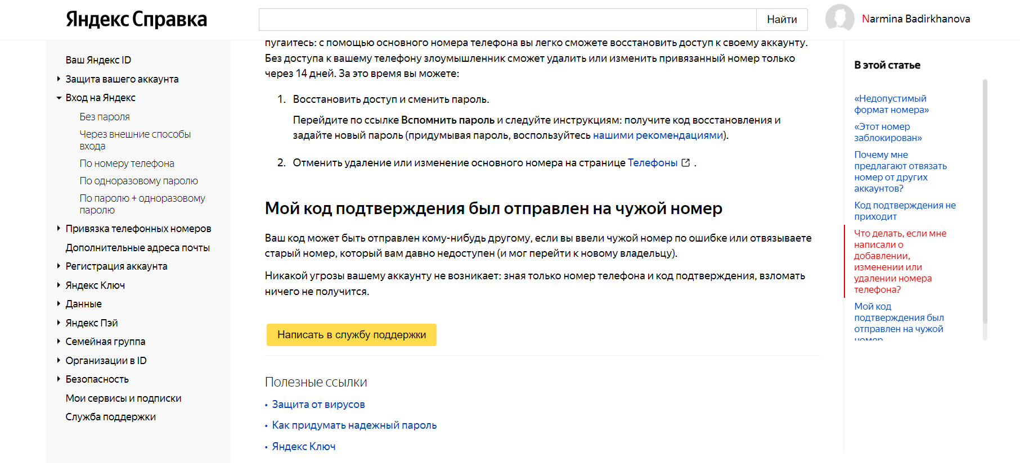

- Enter the required details:

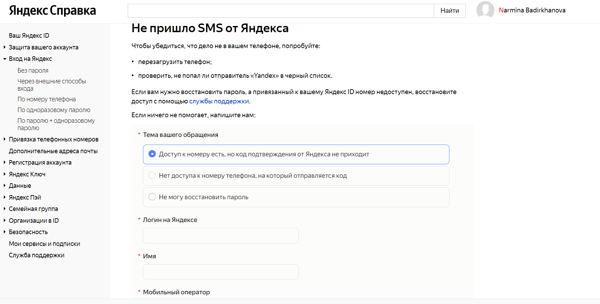
- Use the text of the complaint (English):
Dear Support Team, please note that I'm unable to receive the SMS with the OTP code on my mobile number +994 XXXXXXXXXX. I have raised these issues with my mobile operator, but despite my attempts to resolve them, it appears that SMS messages from your service are not reaching their network.
Please troubleshoot and try rerouting SMS messages to correctly reach my mobile phone (over another SMS connectivity provider). Thank you!

