**Complaint - No receipt of the A2P SMS authentication codes**

Step1 : [Uber Help](https://help.uber.com/)

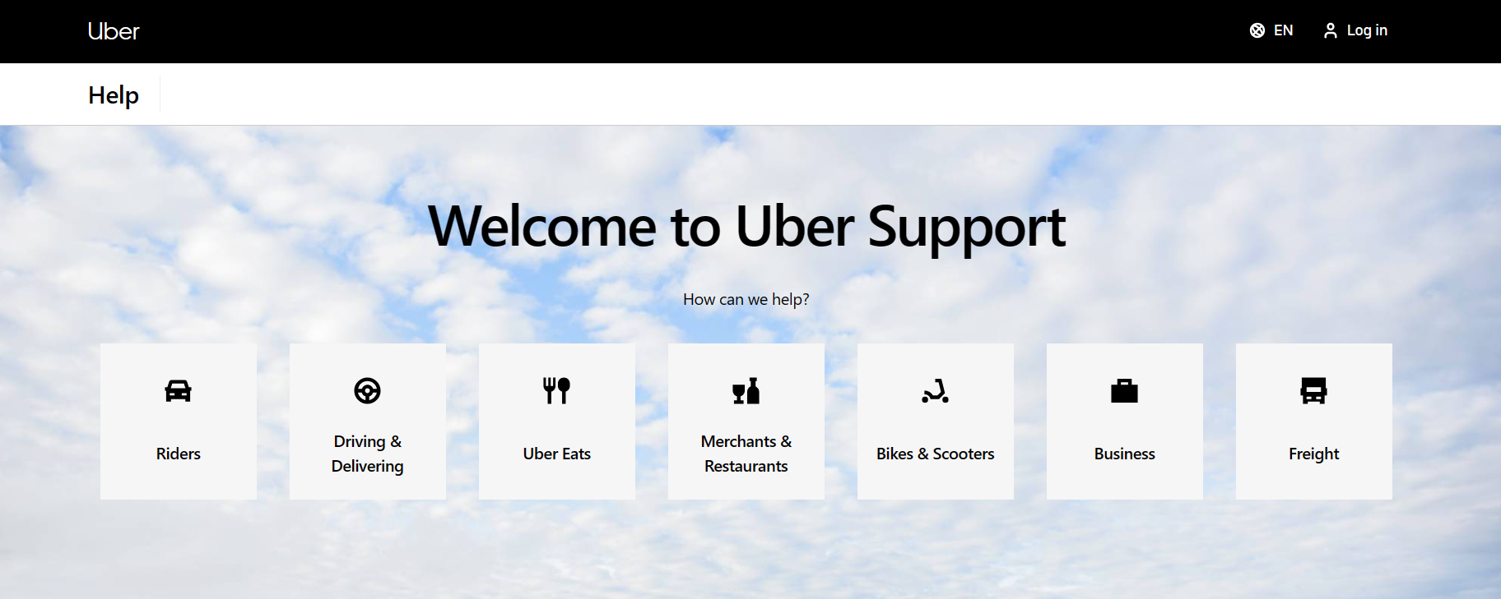

Step 2: Tap on the rider

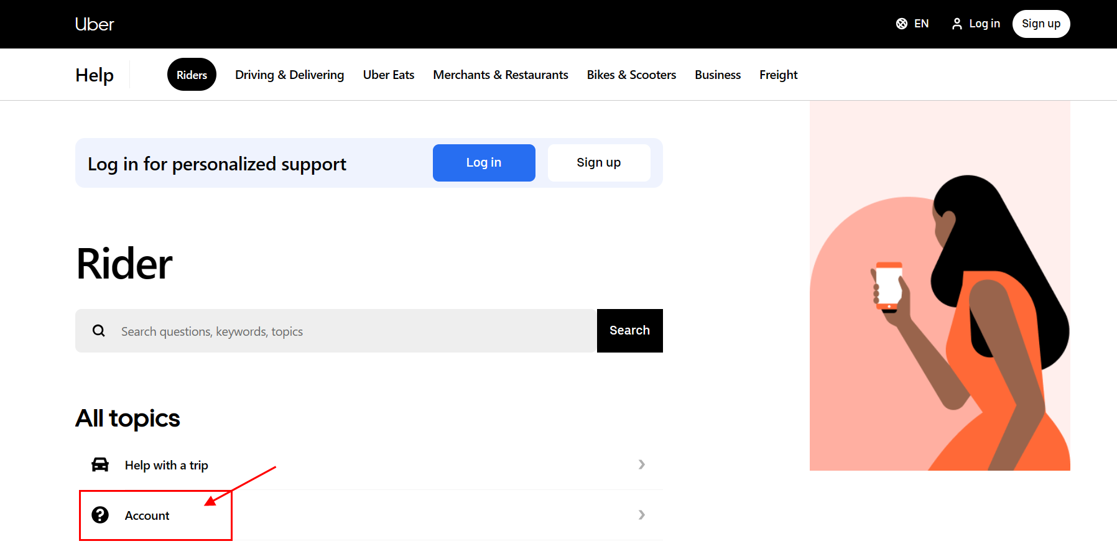

Step 3: Tap on cannot sign up in or request trip:

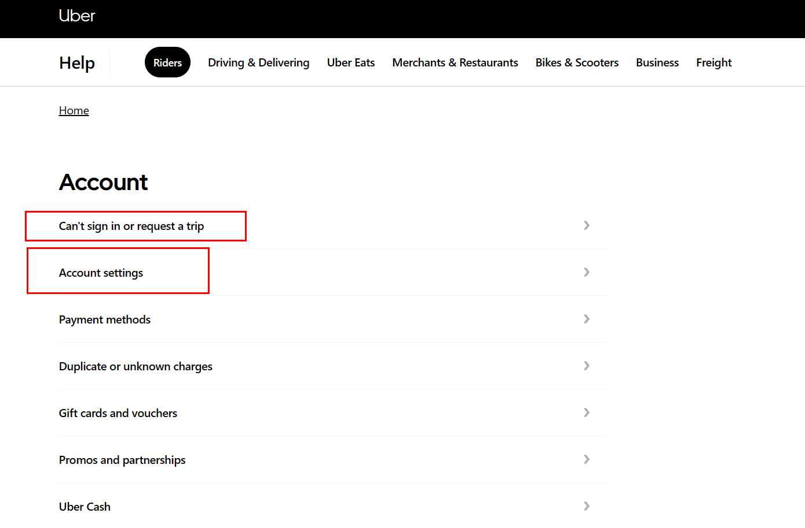

Step 4: Click on I cannot sign in to my account:

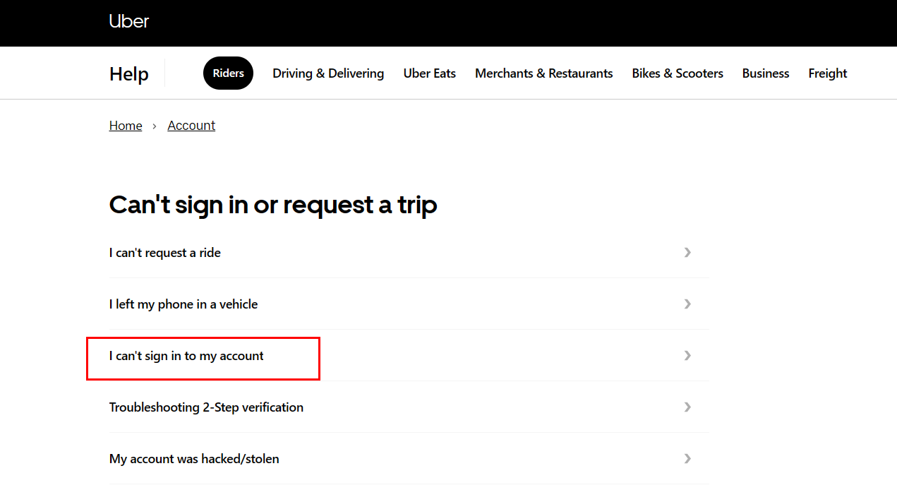

Step 5: Scroll down and click on:

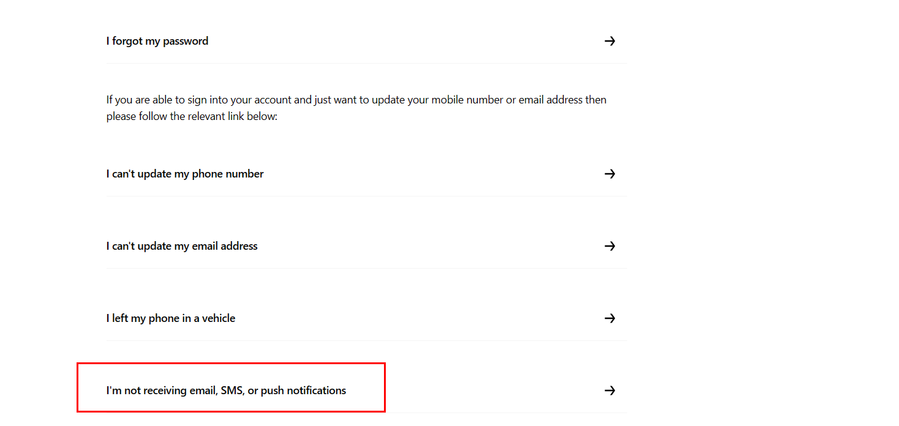

Step 6: Read all the details carefully.

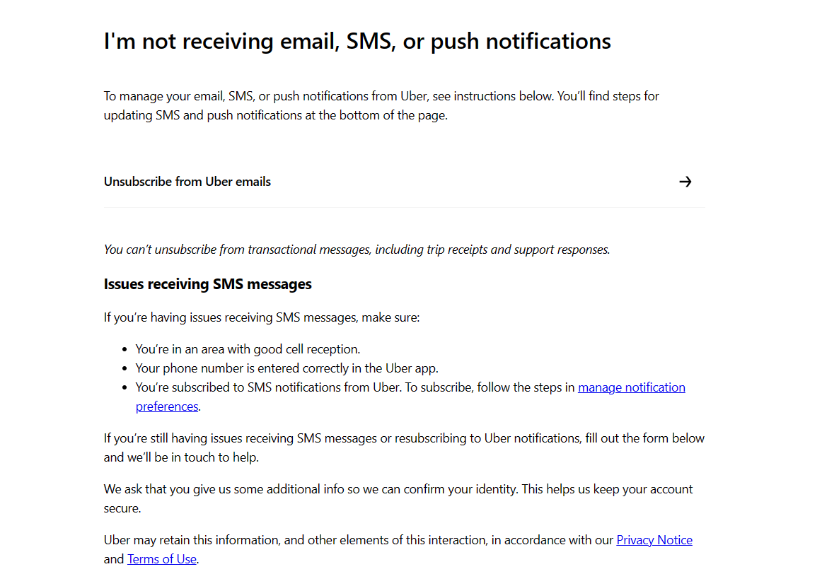

Step 7: Provide details and submit to Uber support

