Complaint - No receipt of the A2P SMS authentication codes

Step 1: Click on the link below:

https://help.instagram.com/374546259294234

Step 2: Go to “Was this helpful?” section located in the right corner of the screen and click on No

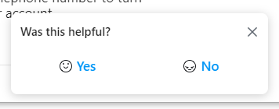

Step 3: Select “The solution doesn’t work” from the information below

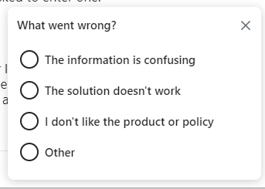

Step 4: Enter the text of the complaint in the message box (English) and update your own number:

Dear Support Team, please note that I'm unable to receive the SMS with the OTP code on my mobile number +994 XXXXXXXXXX. I have raised these issues with my mobile operator, but despite my attempts to resolve them, it appears that SMS messages from your service are not reaching their network. Please troubleshoot and try rerouting SMS messages to correctly reach my mobile phone (over another SMS connectivity provider). Thank you!

