Complaint - No receipt of the A2P SMS authentication codes

Step 1: Click on the link below:
https://support.google.com/accounts/topic/2954345?hl=en&ref_topic=7667090&sjid=602938798107598618-EU

Step 2: Click on the “Contact us” section:

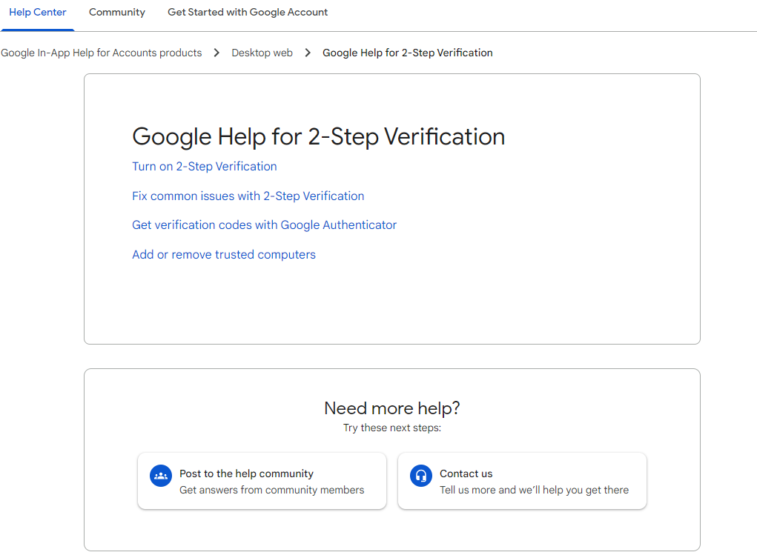

Step 3: Write the issue on the first line: OTP not received, select “Verification code not working”, then click next:
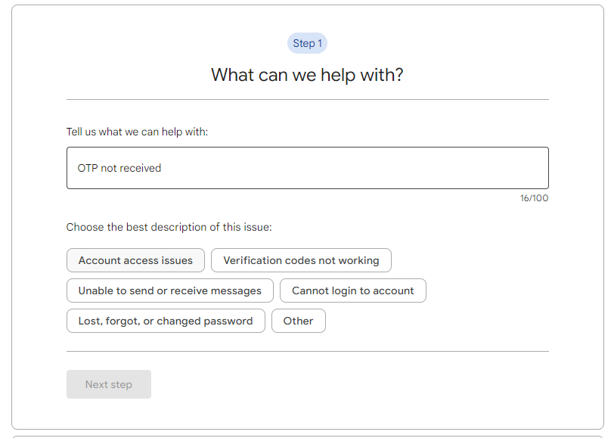

Step 4: Click next at the bottom of the section:

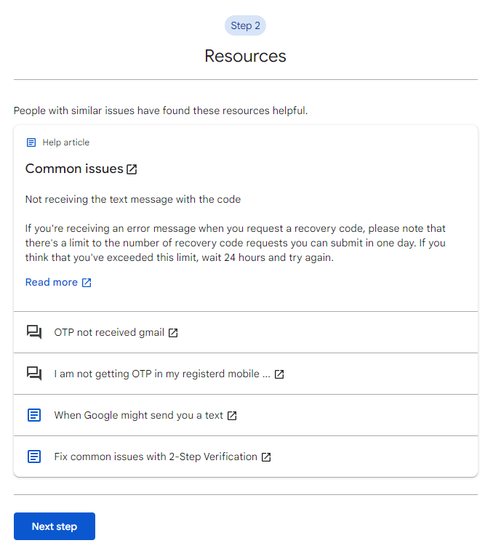

Step 5: Select one of the contact options below to get in touch with their Support:

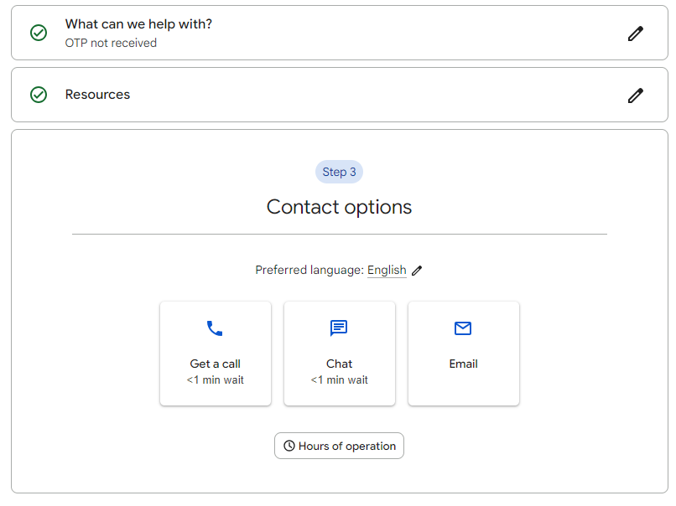

Text of the complaint (English):
Dear Support Team, please note that I'm unable to receive the SMS with the OTP code on my mobile number +994 XXXXXXXXXX. I have raised these issues with my mobile operator, but despite my attempts to resolve them, it appears that SMS messages from your service are not reaching their network.
Please troubleshoot and try rerouting SMS messages to correctly reach my mobile phone (over another SMS connectivity provider). Thank you!

