**Complaint - No receipt of the A2P SMS authentication codes**

**Step 1:** [Support Portal | Bolt](https://bolt.eu/en-gb/support/)

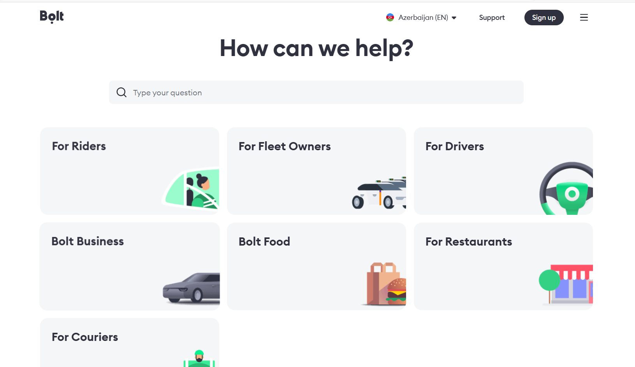

**Step 2:** [Account and data | Bolt](https://bolt.eu/en-gb/support/sections/115000947194/)

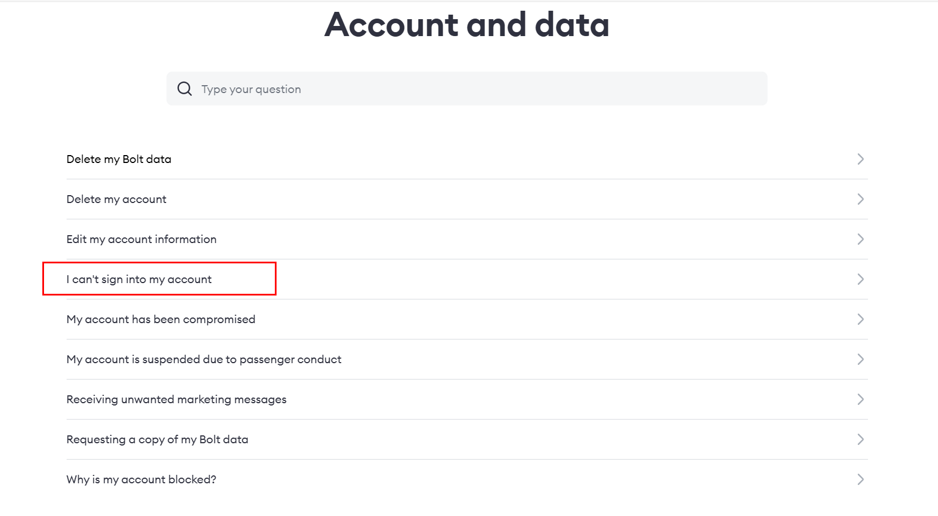

**Step 3:** Read the details and follow the tips:

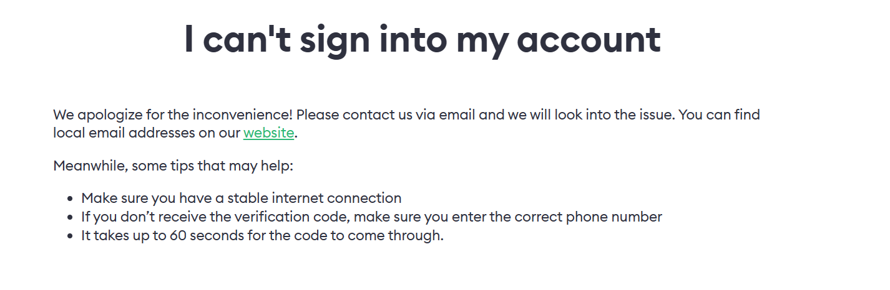

**Step 4:** If these steps do not work then tap on the website link given below. A page of cities will appear select the city and scroll down:  
[Cities: Ride Around the World | Bolt](https://bolt.eu/en/cities/)

**Step 5:** Once you have the support email raise your concern. You will find the email at the end of the page once you have selected the desired city:

**Text of the complaint (English):**

Dear Support Team, please note that I'm unable to receive the SMS with the OTP code on my mobile number +994 XXXXXXXXXX. I have raised these issues with my mobile operator, but despite my attempts to resolve them, it appears that SMS messages from your service are not reaching their network. Please troubleshoot and try rerouting SMS messages to correctly reach my mobile phone (over another SMS connectivity provider). Thank you!